Task 1: Provision the lab environment

In this task, you will deploy four virtual machines into the same Azure region. The first two will reside in a hub virtual network, while each of the remaining two will reside in a separate spoke virtual network

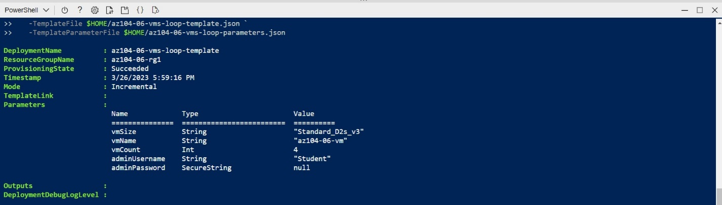

From the Cloud Shell pane, run the following to install the Network Watcher extension on the Azure VMs deployed in the previous step:

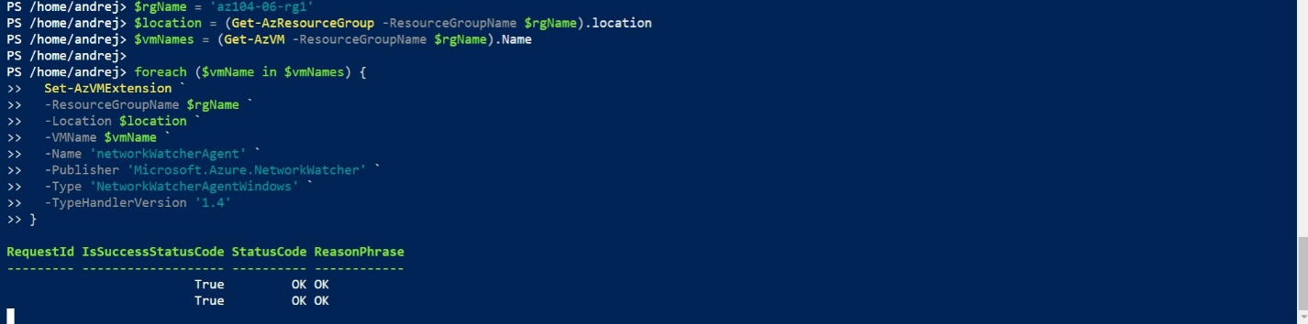

#### Task 2: Configure the hub and spoke network topology

In this task, you will configure local peering between the virtual networks you deployed in the previous tasks in order to create a hub and spoke network topology.

This step establishes two local peerings - one from az104-06-vnet01 to az104-06-vnet2 and the other from az104-06-vnet2 to az104-06-vnet01.

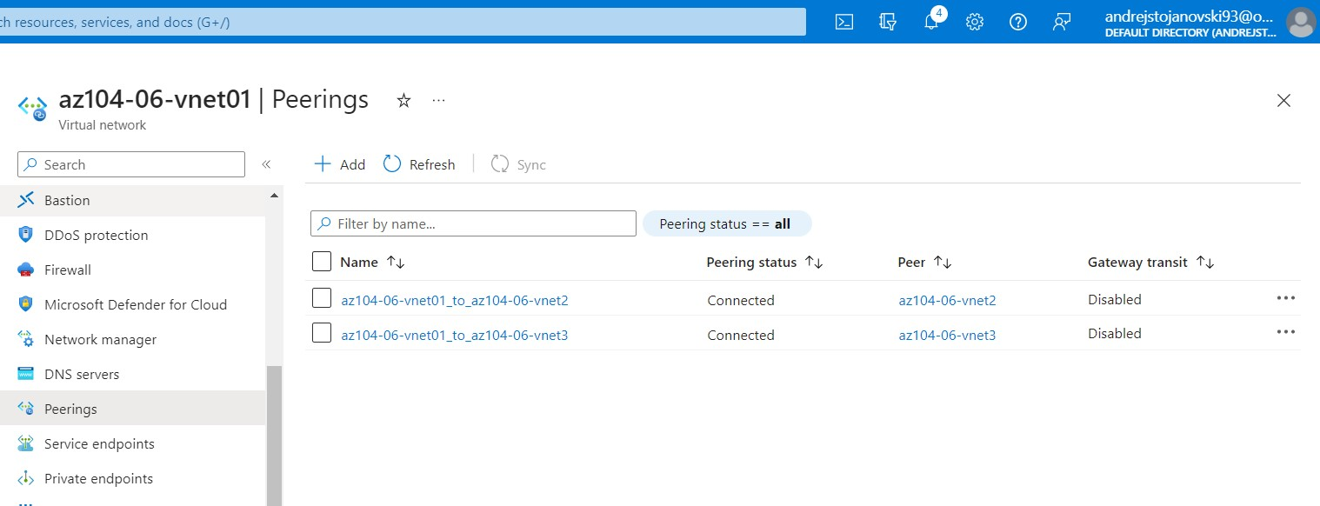

#### Task 3: Test transitivity of virtual network peering

In this task, you will test transitivity of virtual network peering by using Network Watcher.

**Note**: **10.62.0.4** represents the private IP address of **az104-06-vm2**

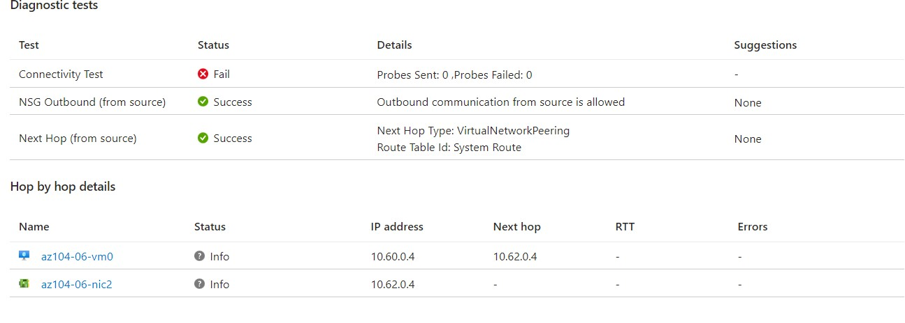

**10.63.0.4** represents the private IP address of **az104-06-vm3**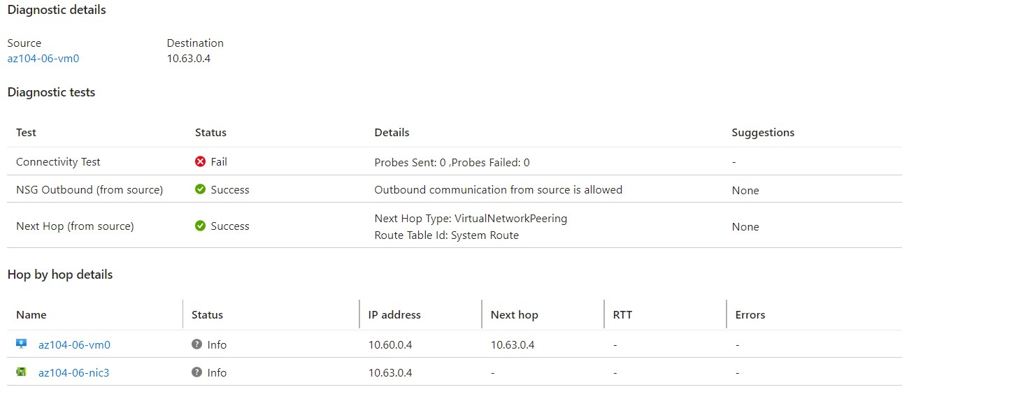

#### Task 4: Configure routing in the hub and spoke topology

In this task, you will configure and test routing between the two spoke virtual networks by enabling IP forwarding on the network interface of the **az104-06-vm0** virtual machine, enabling routing within its operating system, and configuring user-defined routes on the spoke virtual network.

1. On the **az104-06-vm0** blade, in the **Operations** section, click **Run command**, and, in the list of commands, click **RunPowerShellScript**.

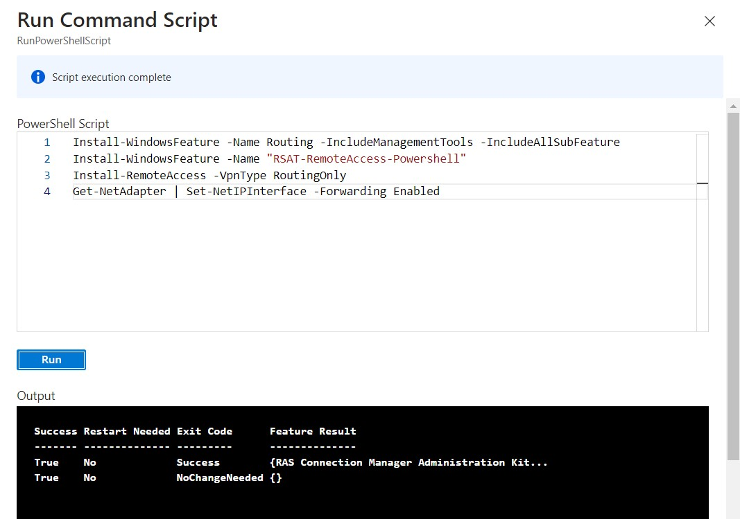

1. In the Azure portal, search and select **Route tables** and, on the **Route tables** blade, click **+ Create**.

On the **Network Watcher - Connection troubleshoot** blade, initiate a check

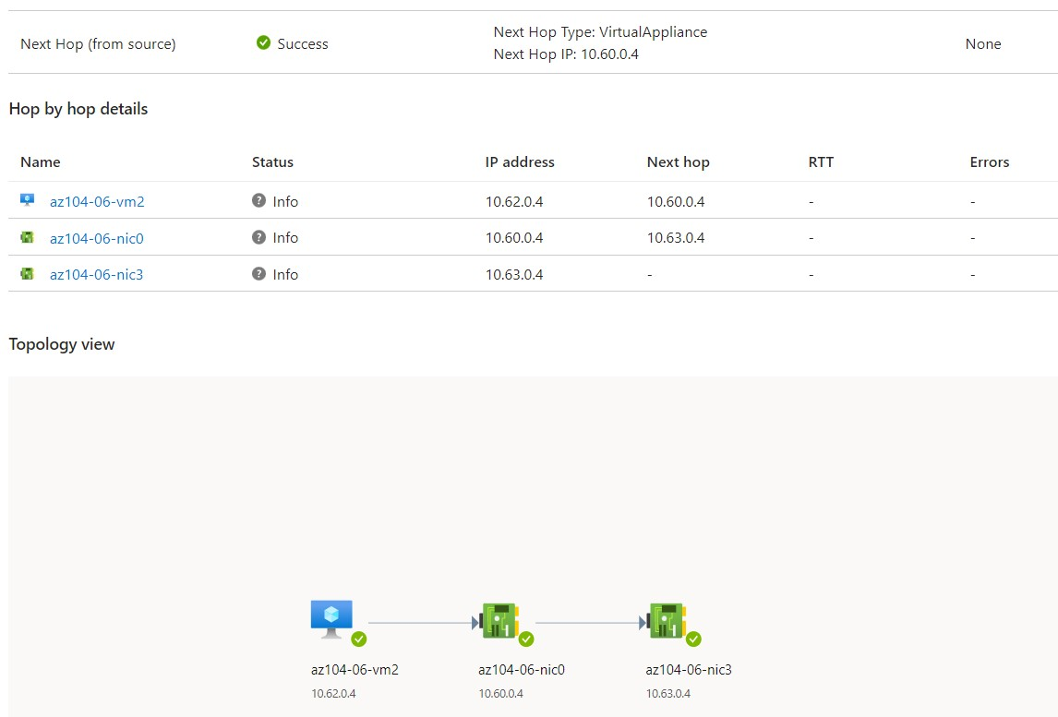

#### Task 5: Implement Azure Load Balancer

In this task, you will implement an Azure Load Balancer in front of the two Azure virtual machines in the hub virtual network. Refresh the window to verify the message changes to the other virtual machine. This demonstrates the load balancer rotating through the virtual machines.

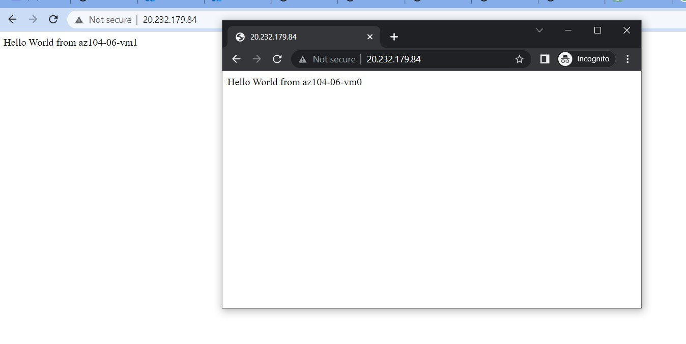

#### Task 6: Implement Azure Application Gateway

1. In the Azure portal, search and select **Application Gateways** and, on the **Application Gateways** blade, click **+ Create**.

Refresh the window to verify the message changes to the other virtual machine.

